**Quốc Khánh 2/9**

Bước 1: Define timer và signal trong app.h thuộc LIFE

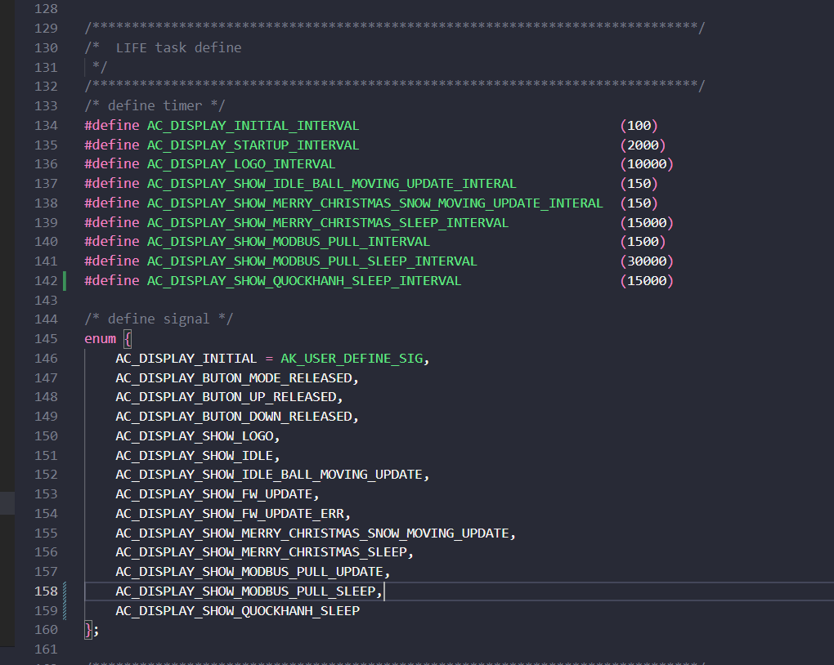

Thêm scr_quockhanh.h vào screens

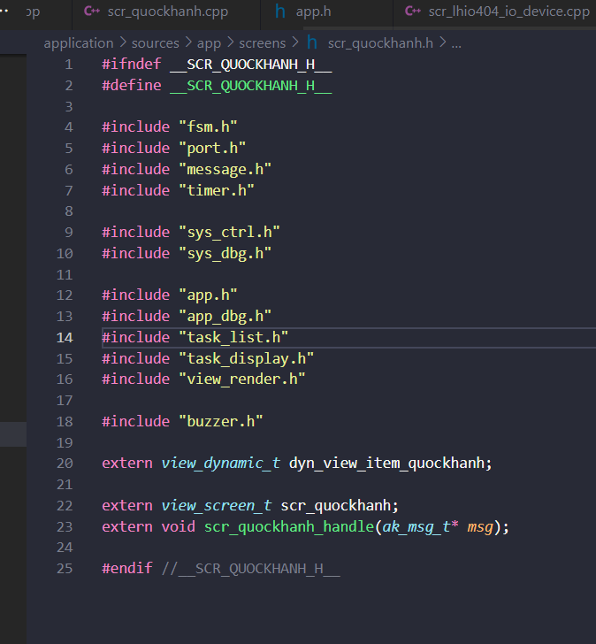

Thêm tone quockhanh vào buzzer.h

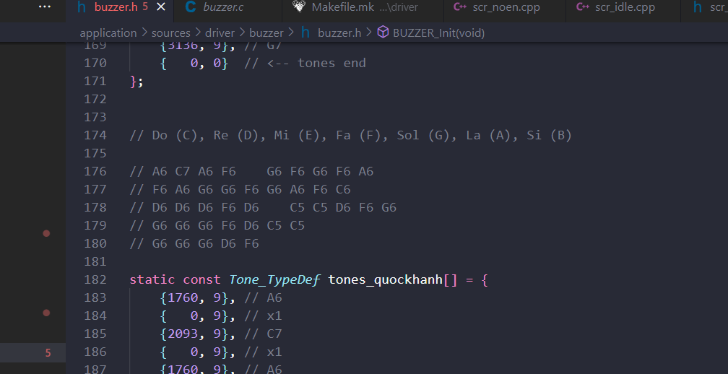

static const *Tone_TypeDef* tones_quockhanh[] = {

    {1760, 9}, // A6

    {   0, 9}, // x1

    {2093, 9}, // C7

    {   0, 9}, // x1

    {1760, 9}, // A6

    {1397, 9}, // F6

    {   0, 18}, // x2

    {1586,9}, // G6

    {   0, 9}, // x1

    {1397, 9}, // F6

    {   0, 9}, // x1

    {1586,9}, // G6

    {   0, 9}, // x1

    {1397, 18}, // F6

    {   0, 9}, // x1

    {1760, 9}, // A6

    {   0, 18}, // x2

    {1397, 9}, // F6

    {   0, 9}, // x1

    {1760, 9}, // A6

    {   0, 9}, // x1

    {1586,12}, // G6

    {   0, 9}, // x1

    {1586,12}, // G6

    {   0, 9}, // x1

    {1397, 9}, // F6

    {   0, 9}, // x1

    {1586,12}, // G6

    {   0, 9}, // x1

    {1760, 9}, // A6

    {   0, 9}, // x1

    {1397, 18}, // F6

    {   0, 9}, // x1

    {1048, 9}, // C6

    {   0, 18}, // x2

    {1174, 9}, // D6

    {   0, 9}, // x1

    {1174, 9}, // D6

    {   0, 9}, // x1

    {1174, 9}, // D6

    {   0, 9}, // x1

    {1397, 9}, // F6

    {   0, 9}, // x1

    {1174, 9}, // D6

    {   0, 9}, // x1

    {524, 9}, // C5

    {   0, 9}, // x1

    {524, 9}, // C5

    {   0, 9}, // x1

    {1174, 9}, // D6

    {   0, 9}, // x1

    {1397, 9}, // F6

    {   0, 9}, // x1

    {1586,12}, // G6

    {   0, 18}, // x2

    {1586,12}, // G6

    {   0, 9}, // x1

    {1586,12}, // G6

    {   0, 9}, // x1

    {1586,12}, // G6

    {   0, 9}, // x1

    {1397, 9}, // F6

    {   0, 9}, // x1

    {1174, 9}, // D6

    {   0, 9}, // x1

    {524, 9}, // C5

    {   0, 9}, // x1

    {524, 9}, // C5

    {   0, 18}, // x2

    {1586,12}, // G6

    {   0, 9}, // x1

    {1586,12}, // G6

    {   0, 9}, // x1

    {1586,12}, // G6

    {   0, 9}, // x1

    {1174, 9}, // D6

    {   0, 9}, // x1

    {1397, 9}, // F6

    {   0, 9}, // x1

    {   0, 0}  // <-- tones end

};

Thêm scr_quockhanh.cpp vào screens

#include "scr_quockhanh.h"

static const unsigned char PROGMEM logo_quockhanh[] = {

    0xff, 0xff, 0xff, 0xff, 0xff, 0xff, 0xff, 0xff, 0xff, 0xff, 0xff, 0xff, 0xff, 0xff, 0xff, 0xff,

    0xff, 0xff, 0xff, 0xff, 0xff, 0xff, 0xff, 0xff, 0xff, 0xff, 0xff, 0xff, 0xff, 0xff, 0xff, 0xff,

    0xff, 0xff, 0xff, 0xff, 0xff, 0xff, 0xff, 0xff, 0xff, 0xff, 0xff, 0xff, 0xff, 0xff, 0xff, 0xff,

    0xff, 0xff, 0xff, 0xff, 0xff, 0xff, 0xff, 0xfe, 0x3f, 0xff, 0xff, 0xff, 0xff, 0xff, 0xff, 0xff,

    0xff, 0xff, 0xff, 0xff, 0xff, 0xff, 0xff, 0xfc, 0x1f, 0xff, 0xff, 0xff, 0xff, 0xff, 0xff, 0xff,

    0xff, 0xff, 0xff, 0xff, 0xff, 0xff, 0xff, 0xfc, 0x1f, 0xff, 0xff, 0xff, 0xff, 0xff, 0xff, 0xff,

    0xff, 0xff, 0xff, 0xff, 0xff, 0xff, 0xff, 0xfc, 0x0f, 0xff, 0xff, 0xff, 0xff, 0xff, 0xff, 0xff,

    0xff, 0xff, 0xff, 0xff, 0xff, 0xff, 0xff, 0xf8, 0x0f, 0xff, 0xff, 0xff, 0xff, 0xff, 0xff, 0xff,

    0xff, 0xff, 0xff, 0xff, 0xff, 0xff, 0xff, 0xf8, 0x0f, 0xff, 0xff, 0xff, 0xff, 0xff, 0xff, 0xff,

    0xff, 0xff, 0xff, 0xff, 0xff, 0xff, 0xff, 0xf0, 0x07, 0xff, 0xff, 0xff, 0xff, 0xff, 0xff, 0xff,

    0xff, 0xff, 0xff, 0xff, 0xff, 0xff, 0xff, 0xf0, 0x07, 0xff, 0xff, 0xff, 0xff, 0xff, 0xff, 0xff,

    0xff, 0xff, 0xff, 0xff, 0xff, 0xff, 0xff, 0xf0, 0x07, 0xff, 0xff, 0xff, 0xff, 0xff, 0xff, 0xff,

    0xff, 0xff, 0xff, 0xff, 0xff, 0xff, 0xff, 0xe0, 0x03, 0xff, 0xff, 0xff, 0xff, 0xff, 0xff, 0xff,

    0xff, 0xff, 0xff, 0xff, 0xff, 0xff, 0xff, 0xe0, 0x83, 0xff, 0xff, 0xff, 0xff, 0xff, 0xff, 0xff,

    0xff, 0xff, 0xff, 0xff, 0xff, 0xff, 0xff, 0xe0, 0x81, 0xff, 0xff, 0xff, 0xff, 0xff, 0xff, 0xff,

    0xff, 0xff, 0xff, 0xff, 0xff, 0xff, 0xff, 0xc1, 0xc1, 0xff, 0xff, 0xff, 0xff, 0xff, 0xff, 0xff,

    0xff, 0xff, 0xff, 0xff, 0xff, 0xf0, 0x00, 0x01, 0xc0, 0x00, 0x07, 0xff, 0xff, 0xff, 0xff, 0xff,

    0xff, 0xff, 0xff, 0xff, 0xff, 0xe0, 0x00, 0x01, 0xc0, 0x00, 0x01, 0xff, 0xff, 0xff, 0xff, 0xff,

    0xff, 0xff, 0xff, 0xff, 0xff, 0xc0, 0x00, 0x03, 0xe0, 0x00, 0x01, 0xff, 0xff, 0xff, 0xff, 0xff,

    0xff, 0xff, 0xff, 0xff, 0xff, 0xc0, 0x00, 0x03, 0xe0, 0x00, 0x01, 0xff, 0xff, 0xff, 0xff, 0xff,

    0xff, 0xff, 0xff, 0xff, 0xff, 0xe0, 0x00, 0x07, 0xf0, 0x00, 0x03, 0xff, 0xff, 0xff, 0xff, 0xff,

    0xff, 0xff, 0xff, 0xff, 0xff, 0xf0, 0x07, 0xff, 0xff, 0xf0, 0x07, 0xff, 0xff, 0xff, 0xff, 0xff,

    0xff, 0xff, 0xff, 0xff, 0xff, 0xfc, 0x01, 0xff, 0xff, 0xc0, 0x1f, 0xff, 0xff, 0xff, 0xff, 0xff,

    0xff, 0xff, 0xff, 0xff, 0xff, 0xfe, 0x00, 0xff, 0xff, 0x80, 0x3f, 0xff, 0xff, 0xff, 0xff, 0xff,

    0xff, 0xff, 0xff, 0xff, 0xff, 0xff, 0x80, 0x3f, 0xfe, 0x00, 0xff, 0xff, 0xff, 0xff, 0xff, 0xff,

    0xff, 0xff, 0xff, 0xff, 0xff, 0xff, 0xc0, 0x1f, 0xfc, 0x01, 0xff, 0xff, 0xff, 0xff, 0xff, 0xff,

    0xff, 0xff, 0xff, 0xff, 0xff, 0xff, 0xf0, 0x1f, 0xfc, 0x07, 0xff, 0xff, 0xff, 0xff, 0xff, 0xff,

    0xff, 0xff, 0xff, 0xff, 0xff, 0xff, 0xf8, 0x1f, 0xfc, 0x0f, 0xff, 0xff, 0xff, 0xff, 0xff, 0xff,

    0xff, 0xff, 0xff, 0xff, 0xff, 0xff, 0xf8, 0x1f, 0xfe, 0x0f, 0xff, 0xff, 0xff, 0xff, 0xff, 0xff,

    0xff, 0xff, 0xff, 0xff, 0xff, 0xff, 0xf8, 0x3f, 0xfe, 0x0f, 0xff, 0xff, 0xff, 0xff, 0xff, 0xff,

    0xff, 0xff, 0xff, 0xff, 0xff, 0xff, 0xf8, 0x3c, 0x1e, 0x0f, 0xff, 0xff, 0xff, 0xff, 0xff, 0xff,

    0xff, 0xff, 0xff, 0xff, 0xff, 0xff, 0xf0, 0x78, 0x0f, 0x07, 0xff, 0xff, 0xff, 0xff, 0xff, 0xff,

    0xff, 0xff, 0xff, 0xff, 0xff, 0xff, 0xf0, 0x60, 0x03, 0x07, 0xff, 0xff, 0xff, 0xff, 0xff, 0xff,

    0xff, 0xff, 0xff, 0xff, 0xff, 0xff, 0xf0, 0x00, 0x00, 0x03, 0xff, 0xff, 0xff, 0xff, 0xff, 0xff,

    0xff, 0xff, 0xff, 0xff, 0xff, 0xff, 0xe0, 0x00, 0x00, 0x03, 0xff, 0xff, 0xff, 0xff, 0xff, 0xff,

    0xff, 0xff, 0xff, 0xff, 0xff, 0xff, 0xe0, 0x00, 0x80, 0x03, 0xff, 0xff, 0xff, 0xff, 0xff, 0xff,

    0xff, 0xff, 0xff, 0xff, 0xff, 0xff, 0xe0, 0x03, 0xe0, 0x01, 0xff, 0xff, 0xff, 0xff, 0xff, 0xff,

    0xff, 0xff, 0xff, 0xff, 0xff, 0xff, 0xc0, 0x0f, 0xf8, 0x01, 0xff, 0xff, 0xff, 0xff, 0xff, 0xff,

    0xff, 0xff, 0xff, 0xff, 0xff, 0xff, 0xc0, 0x1f, 0xfc, 0x01, 0xff, 0xff, 0xff, 0xff, 0xff, 0xff,

    0xff, 0xff, 0xff, 0xff, 0xff, 0xff, 0xc0, 0x7f, 0xff, 0x01, 0xff, 0xff, 0xff, 0xff, 0xff, 0xff,

    0xff, 0xff, 0xff, 0xff, 0xff, 0xff, 0xc1, 0xff, 0xff, 0xc1, 0xff, 0xff, 0xff, 0xff, 0xff, 0xff,

    0xff, 0xff, 0xff, 0xff, 0xff, 0xff, 0xe3, 0xff, 0xff, 0xe3, 0xff, 0xff, 0xff, 0xff, 0xff, 0xff,

    0xff, 0xff, 0xff, 0xff, 0xff, 0xff, 0xff, 0xff, 0xff, 0xff, 0xff, 0xff, 0xff, 0xff, 0xff, 0xff,

    0xff, 0xff, 0xff, 0xff, 0xff, 0xff, 0xff, 0xff, 0xff, 0xff, 0xff, 0xff, 0xff, 0xff, 0xff, 0xff,

    0xff, 0xff, 0xff, 0xff, 0xff, 0xff, 0xff, 0xff, 0xff, 0xff, 0xff, 0xff, 0xff, 0xff, 0xff, 0xff,

    0xff, 0xff, 0xff, 0xff, 0xff, 0xff, 0xff, 0xff, 0xff, 0xff, 0xff, 0xff, 0xff, 0xff, 0xff, 0xff,

    0xff, 0xff, 0xff, 0xff, 0xff, 0xff, 0xff, 0xff, 0xff, 0xff, 0xff, 0xff, 0xff, 0xff, 0xff, 0xff,

    0xff, 0xff, 0xff, 0xff, 0xff, 0xff, 0xff, 0xff, 0xff, 0xff, 0xff, 0xff, 0xff, 0xff, 0xff, 0xff,

    0xff, 0xff, 0xff, 0xff, 0xf9, 0x7f, 0xff, 0xf7, 0xfe, 0x7f, 0xe7, 0xff, 0xff, 0xbf, 0xff, 0xff,

    0xff, 0xff, 0xe1, 0xff, 0xf0, 0xff, 0xf3, 0xb3, 0xfe, 0xff, 0xe7, 0xfe, 0x1f, 0x38, 0x7f, 0xff,

    0xff, 0xff, 0x80, 0xff, 0xff, 0xff, 0xf3, 0x33, 0xff, 0xff, 0xe7, 0xfc, 0x0f, 0x30, 0x7f, 0xff,

    0xff, 0xff, 0x9e, 0x6e, 0xf9, 0xf3, 0xf2, 0x72, 0x78, 0xfc, 0xe4, 0xff, 0x8f, 0x77, 0x3f, 0xff,

    0xff, 0xff, 0x9e, 0x66, 0x60, 0x61, 0xf0, 0xf0, 0x30, 0x60, 0x60, 0x7f, 0x9e, 0x73, 0x3f, 0xff,

    0xff, 0xff, 0xbe, 0x66, 0x66, 0x47, 0xf0, 0xf3, 0x3e, 0x66, 0x66, 0x7f, 0x9e, 0x70, 0x3f, 0xff,

    0xff, 0xff, 0x9e, 0x66, 0x6e, 0x4f, 0xf2, 0x73, 0x30, 0x67, 0x66, 0x7f, 0x3e, 0xfd, 0x3f, 0xff,

    0xff, 0xff, 0x9c, 0x66, 0x66, 0x4f, 0xf2, 0x33, 0x32, 0x67, 0x66, 0x7e, 0x7c, 0xff, 0x7f, 0xff,

    0xff, 0xff, 0x80, 0xe0, 0x60, 0x61, 0xf3, 0x33, 0x30, 0x67, 0x66, 0x7c, 0x0c, 0xf0, 0x7f, 0xff,

    0xff, 0xff, 0xe0, 0x72, 0xf1, 0xf3, 0xfb, 0xb7, 0xb9, 0x67, 0x67, 0x7c, 0x0d, 0xf8, 0xff, 0xff,

    0xff, 0xff, 0xff, 0x3f, 0xff, 0xff, 0xff, 0xff, 0xff, 0xff, 0xff, 0xff, 0xf9, 0xff, 0xff, 0xff,

    0xff, 0xff, 0xff, 0xff, 0xff, 0xff, 0xff, 0xff, 0xff, 0xff, 0xff, 0xff, 0xf9, 0xff, 0xff, 0xff,

    0xff, 0xff, 0xff, 0xff, 0xff, 0xff, 0xff, 0xff, 0xff, 0xff, 0xff, 0xff, 0xff, 0xff, 0xff, 0xff,

    0xff, 0xff, 0xff, 0xff, 0xff, 0xff, 0xff, 0xff, 0xff, 0xff, 0xff, 0xff, 0xff, 0xff, 0xff, 0xff,

    0xff, 0xff, 0xff, 0xff, 0xff, 0xff, 0xff, 0xff, 0xff, 0xff, 0xff, 0xff, 0xff, 0xff, 0xff, 0xff,

    0xff, 0xff, 0xff, 0xff, 0xff, 0xff, 0xff, 0xff, 0xff, 0xff, 0xff, 0xff, 0xff, 0xff, 0xff, 0xff

};

static void view_scr_quockhanh();

*view_dynamic_t* dyn_view_item_quockhanh = {

    {

        .item_type = ITEM_TYPE_DYNAMIC,

    },

    view_scr_quockhanh

};

*view_screen_t* scr_quockhanh = {

    &dyn_view_item_quockhanh,

    ITEM_NULL,

    ITEM_NULL,

    .focus_item = 0,

};

void view_scr_quockhanh() {

    view_render.clear();

    view_render.drawBitmap(0,0,logo_quockhanh, 128, 64, 1);

    view_render.update();

}

void scr_quockhanh_handle(*ak_msg_t*\* *msg*) {

    switch (*msg*->sig) {

    case SCREEN_ENTRY: {

        APP_DBG_SIG("SCREEN_ENTRY\n");

        BUZZER_PlayTones(tones_quockhanh);

        timer_set(AC_TASK_DISPLAY_ID, \

                  AC_DISPLAY_SHOW_QUOCKHANH_SLEEP, \

                  AC_DISPLAY_SHOW_QUOCKHANH_SLEEP_INTERVAL, \

                  TIMER_ONE_SHOT);

    }

        break;

    case AC_DISPLAY_SHOW_QUOCKHANH_SLEEP: {

        APP_DBG_SIG("AC_DISPLAY_SHOW_MERRY_CHRISTMAS_SLEEP\n");

        SCREEN_TRAN(scr_idle_handle, &scr_idle);

    }

        break;

    case AC_DISPLAY_BUTON_MODE_RELEASED: {

        APP_DBG_SIG("AC_DISPLAY_BUTON_MODE_RELEASED\n");

        SCREEN_TRAN(scr_idle_handle, &scr_idle);

    }

        break;

    case AC_DISPLAY_BUTON_UP_RELEASED: {

        APP_DBG_SIG("AC_DISPLAY_BUTON_UP_RELEASED\n");

        SCREEN_TRAN(scr_idle_handle, &scr_idle);

    }

        break;

    case AC_DISPLAY_BUTON_DOWN_RELEASED: {

        APP_DBG_SIG("AC_DISPLAY_BUTON_DOWN_RELEASED\n");

        SCREEN_TRAN(scr_idle_handle, &scr_idle);

    }

        break;

    default:

        break;

    }

}

Khai báo thư viện scr_quockhanh.h vào task_display.h

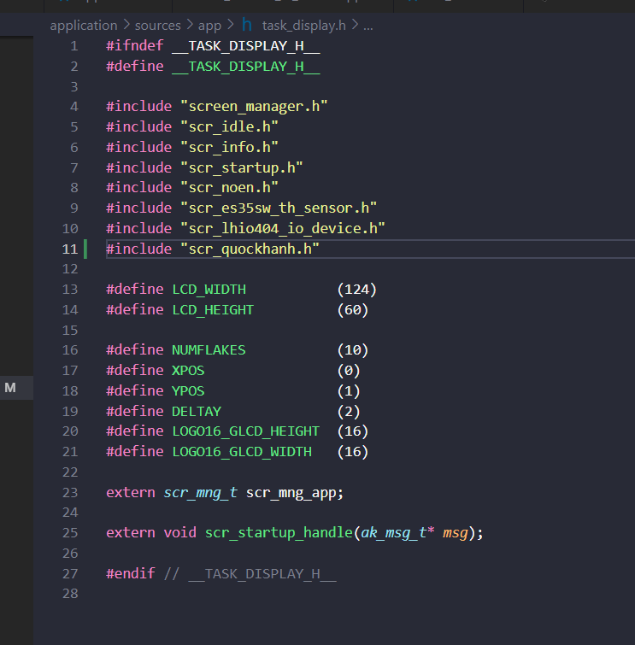

Chỉnh sửa file scr_idle.cpp

